(Approx. 1013 words)

Tom’s Tech-Notes
Review: The Amazon Fire Stick, a Plug-in Streaming Device for Internet TV Services Tom Burt, Vice President, Sun City Summerlin Computer Club, NV
September 2018 issue, The Gigabyte Gazette
www.scscc.club/
tomburt89134 (at) cox.net

Overview
During the mid-July “Amazon Prime Day” sales, Mrs. Burt and I ordered an Amazon Fire Stick device. It was on sale for half price - $19.99. At that price, we figured what have we got to lose? The Fire Stick device plugs into an HDMI port on your HDTV and then, after some simple setup steps, connects to the Internet via your Wi-Fi router. It turns your HDTV into a “smart” TV. It comes with all the usual apps for streaming TV services like Netflix, Hulu, YouTube, Pandora and, of course, Prime Video.
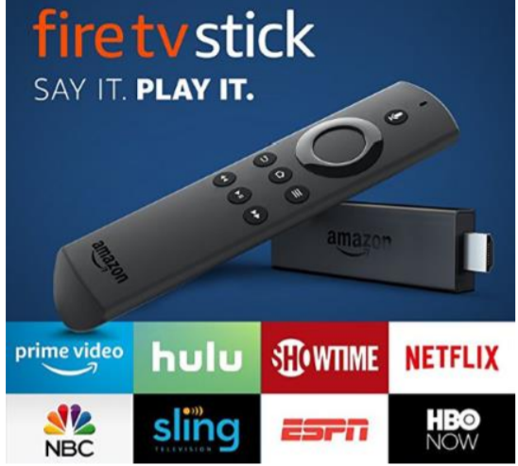
The Fire Stick regularly sells for $39.99 at Amazon.com. You can find details and specs at: https://www.amazon.com/dp/B00ZV9RDKK/ref_=fs_ods_fs_smp_tk.

Included with the Fire Stick is a compact, easy-to use remote that includes a microphone that allows you to talk to Amazon’s Alexa to control the Fire Stick with your voice.

This article will discuss our experience after about a month of use.

Setting Up the Fire Stick
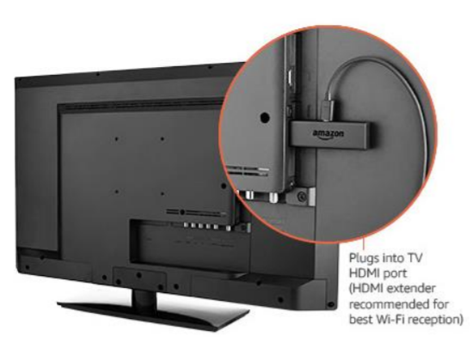
The package contains the Fire Stick itself, the remote, a HDMI extender cable, two AAA batteries and a power / adapter cord. The power cord has a micro USB jack on one end that plugs into the Fire Stick and a regular USB connector on the other end. The regular USB connector plugs into a USB socket on the small power adapter.
I plugged the Fire Stick into my HDTV’s HDMI 2 port, using the HDMI extender cable for better clearance. (My DirecTV receiver is connected to the TV’s HDMI 1 port.) I first tried plugging the USB connector of the power cable into my Samsung HDTV’s USB jack, but found that the USB jack wasn’t putting out enough power. So, I used the power adapter and plugged it into a surge protector next to the HDTV.

I used my Samsung HDTV’s remote to select HDMI 2 as the Input Source. That gave control of the screen to the Fire Stick.

Next, I put the two AAA batteries into the Fire Stick’s remote and then let the remote find the Firestick. From there, I followed the on-screen prompts to connect the Fire Stick to my Wi-Fi router.

To use the Prime Video service, you must be an Amazon Prime subscriber and you must log in with those account credentials. For other paid services like Netflix, you need an active account and, the first time, will need to enter your account credentials for the service.

Using the Fire Stick
Our Samsung HDTV already had “smart features”, but the performance of the apps was spotty with very slow connections and frequent dropouts and pixilation. I think the TV’s internal Wi-Fi components were not powerful enough to do a good job.

By contrast, the Fire Stick has been amazing – quick connections with rock solid and very clear pictures and clean, clear sound. It’s Wi-Fi is 802.11ac, which my Netgear home router supports. I’ve had no trouble with dropped signals and we don’t see any buffering.

The Fire Stick remote is easy to use with a ring in place of the four arrow keys. It’s light and small enough to fit any hand comfortably. The Fire Stick is very responsive to clicks on the remote.

I’ve tried the remote’s Alexa voice control, which is very nice for searching and works well. However, most of the time we use the navigation ring to click around. The on-screen graphics are eye-friendly, and the navigation is easy to figure out. When I want to browse to see what’s available on a service like Prime Video or Netflix, I still favor using my desktop PC because the mouse and keyboard are more efficient for navigating. When I find something of interest, I add it to my watch list for that service and then it’s easy to get to on the Fire Stick.

Fire Stick Apps
Unlike my Samsung TV’s “smart” apps which are a limited set and don’t get updated, the Fire Stick is designed to let the user decide which Apps are installed. There are hundreds to choose from, aside from those that come pre-installed on the Fire Stick. There are also many games that you can download and install. The Fire Stick has 8 GB of storage, so it’s possible to have many Apps installed. The Fire Stick has a built-in web browser, but you can also install the Firefox browser. With a web browser, you can go to any website that has streaming content and watch it, even if there’s no specific App for it. Here’s a link to an article from FireStickTricks.com listing 20 recommended paid and free Apps: https://www.firesticktricks.com/amazon-fire-stick-apps.html

Prime Video
At present, since we’ve subscribed to the Amazon Prime service; we’re also able to get the Amazon Prime Video service at no extra charge. Prime Video features many movies and TV series, but also has some great original content. Over the summer we’ve been re-watching all 9 seasons of the Hugh Laurie “House, MD” series and the Prime original “Bosch” series featuring Titus Welliver. The offerings get updated frequently. The streaming video quality is great, and the content is all “on demand.” And, if you doze off while watching an episode, you can go back and watch it again.

Conclusions
We’re quite happy with the Fire Stick. I’d definitely recommend it if you don’t already own an Apple TV or Roku device, which offer similar functionality. The Fire Stick is far better than the built-in “smart” features of my Samsung HDTV. As a vehicle for “cord cutting” the Fire Stick is interesting because it can access so many sources for content. Among its available Apps is one for “DirecTV Now,” which is a streaming version of DirecTV that currently costs quite a bit less than the satellite version. There’s also an App for Sling TV, which is another streaming service that offers a lot of “cable” channels at very low rates.

